Tokoroa Central School
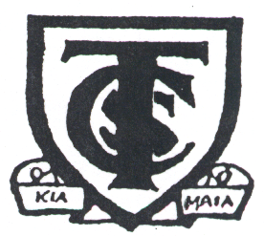
Te Kura Manawa o Tokoroa
TELEPHONE / FAX CLYDE STREET
(07)8866780 P.O. BOX 643
e-mail:
principal@tokoroacentral.school.nz TOKOROA 3444
office@tokoroacentral.school.nz

PRINCIPAL: Debbie Follas CHAIRPERSON: Johnny Drydon

Re: Fixed Term Teaching Positions 2020

Dear Applicant

Thank you for inquiring about the Scale A position, as recently advertised online in the New Zealand Education Gazette.
The job description for this position is based on the professional standards for teachers, as stated in the relevant NZEI Collective Agreement, and the Code of Professional Responsibility and Standards for the Teaching Profession
Should you decide to proceed with your application, we require from you the following:
- Curriculum Vitae
  - Cover Letter
  - Completed Application Form

Please send these electronically in PDF to Debbie Follas, Principal principal@tokoroacentral.school.nz

Applications close on Friday 18 October 2019, 12:00 pm.
Shortlisted applicants will be contacted for an interview time on Friday 18 October 2019,
In the evening.
We will arrange an interview day/time, the week of 21-26th October 2-19. All interviews will be held during this week with applicants notified of the outcome on the 26th/27th October.

Should you have any concerns or queries, please contact me, phone 027 245 0729 or email principal@tokoroacentral.school.nz.school.nz

To discover more about our school please visit our website or our Facebook page. https://www.facebook.com/TokoroaCentralSchool/
https://tokoroacentral.school.nz/

I would like to take this opportunity to thank you for your interest in our position.
Yours Sincerely

Debbie Follas
Principal

